**Test Evidence – “Job Ads Checkout system”**

This is a sample app for templating my knowledge with Ruby, EJS, Node and Express.

In order to test this, you will need to install the libraries: express, ejs and sqlite3.

The sqlite3 module also works with “node-webkit” if node-webkit contains a supported version of “Node.js” engine.

Use in console:

npm install express  
npm i --save sqlite3

You can run this by putting it in a file called "app.js" and running it with **node app.js** with everything from simple terminal output.

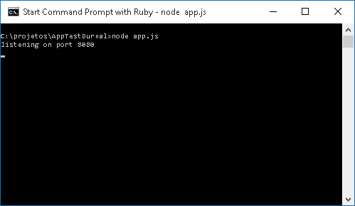

This test application listen on port 8080, IP defaults to 127.0.0.1 (<http://127.0.0.1:8080/>). Open in any browser to see the following result.

**Home Page**

The home page shows my information more quickly with access to my contact and resume, but mainly to “Test Application” as you can see below.

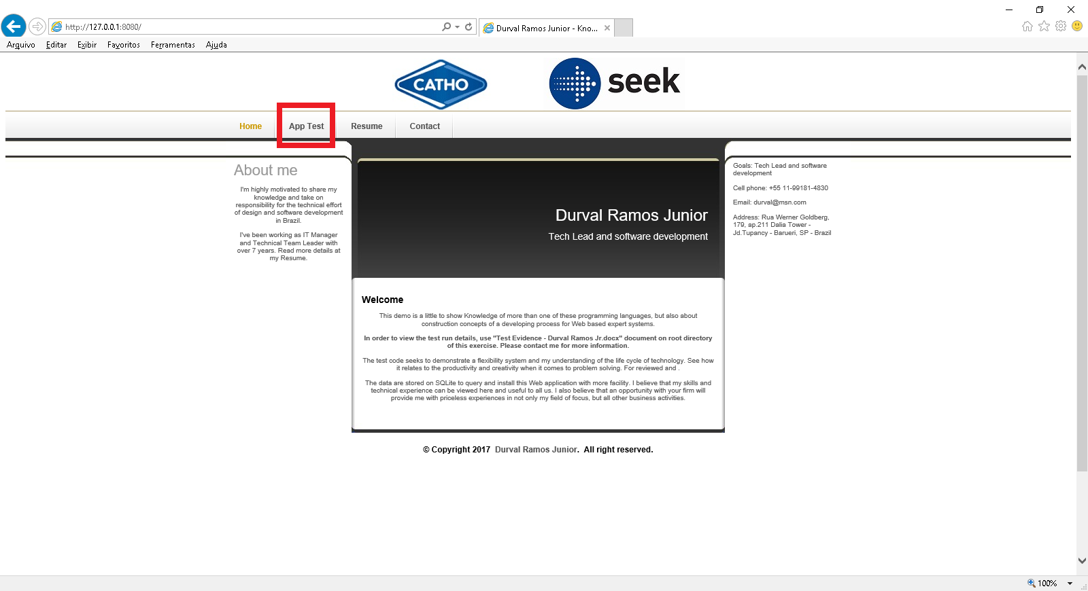

**App Test**

After clicking on a “App Test” menu you can see my knowledge test and a submenu:

* Job ads checkout system
* “Products” form
* “Customers” form
* “Price Rules” form

The “Job ads checkout system” option load the purpose of this exercise.

The others forms is only one demonstration that can result to dynamic data query based fulfils the requirements described to define special pricing for a small number of privileged customers.

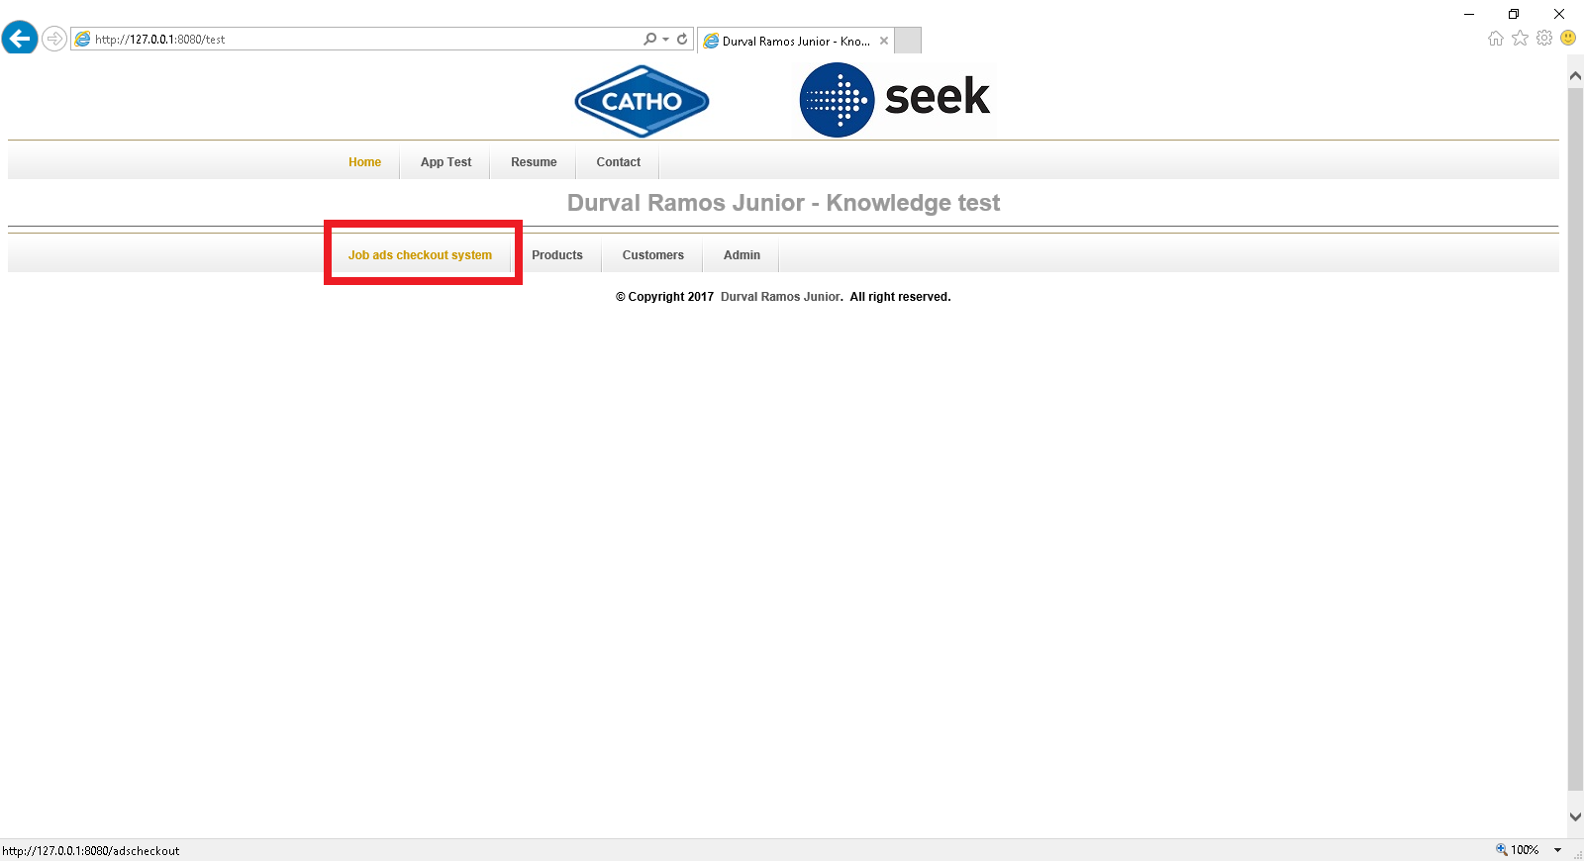

**“Job ads checkout” system**

Query dynamic content by related data to Customers for each Product, offer different rules.

As a result, the recruiters can can select from Product with a special discount.

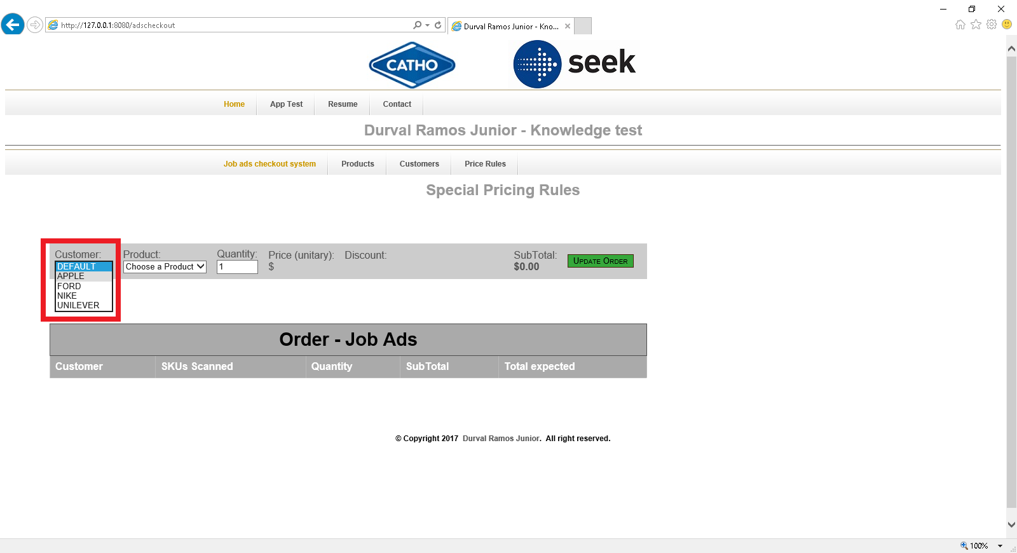

Each Customer has offer product is billed as follows:

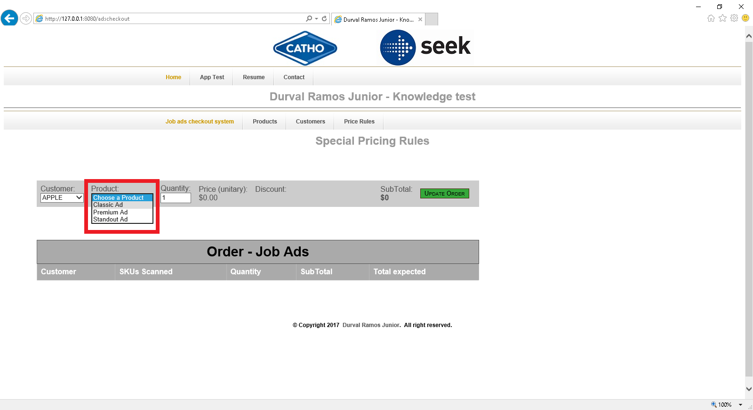

When discount bonds can be bought a description is available. In some cases, the price has automatic processing to reduce the bill calculating the subtotal price for each product.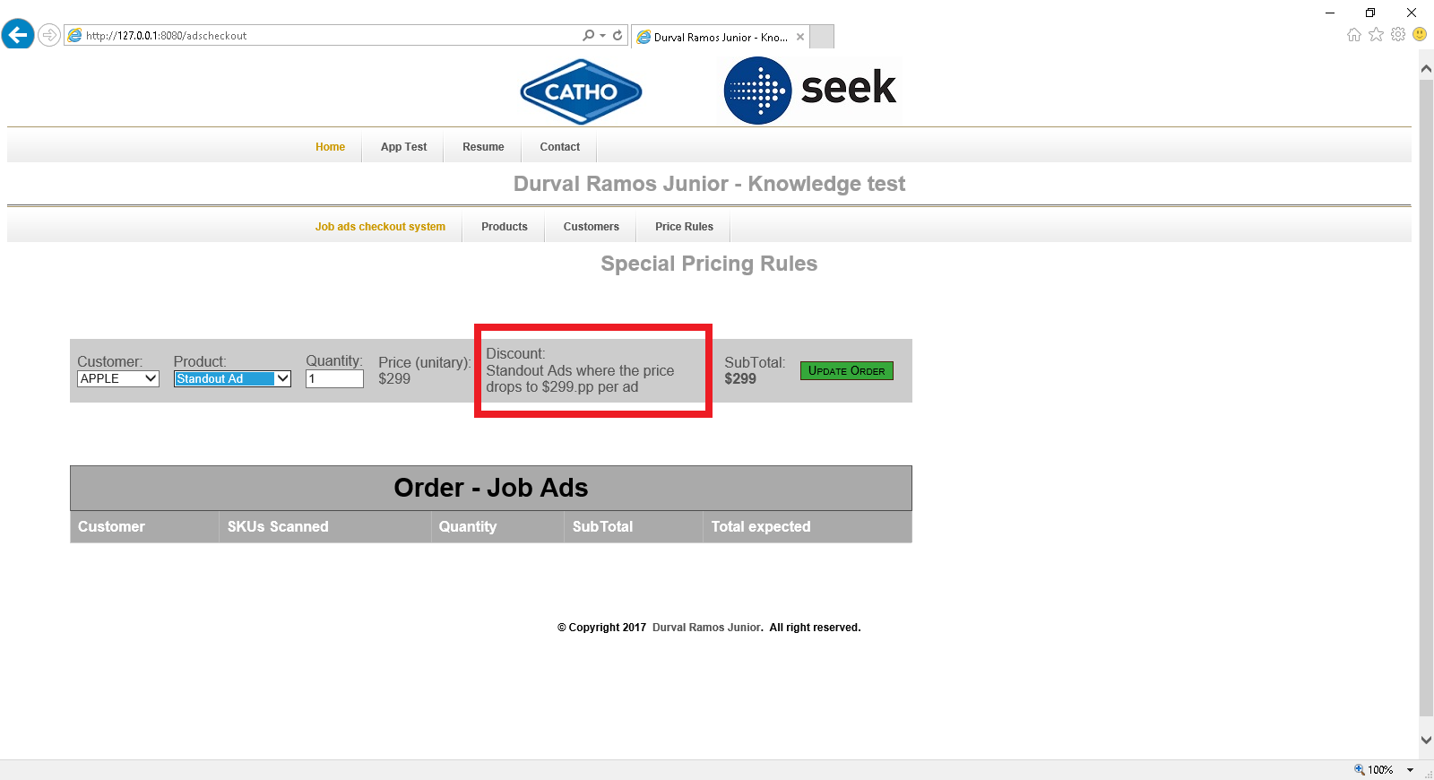

When you change the value “Quantity” field then replace the “Subtotal”.

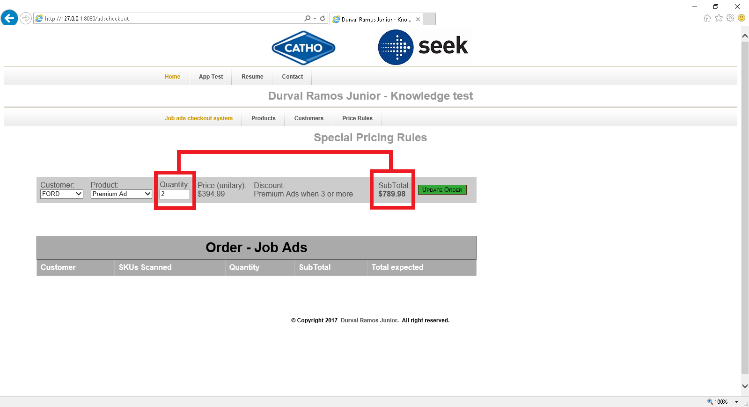

To add a new product to each Customer you can click on “Update Order” button. The “Order – Jobs Ads” grid will be filled with data: Customer, Product, Quantity and Subtotal (Quantity x Unity price). If you have others products the “Total” field will be updated.

You may include more products per Customer if you wish.

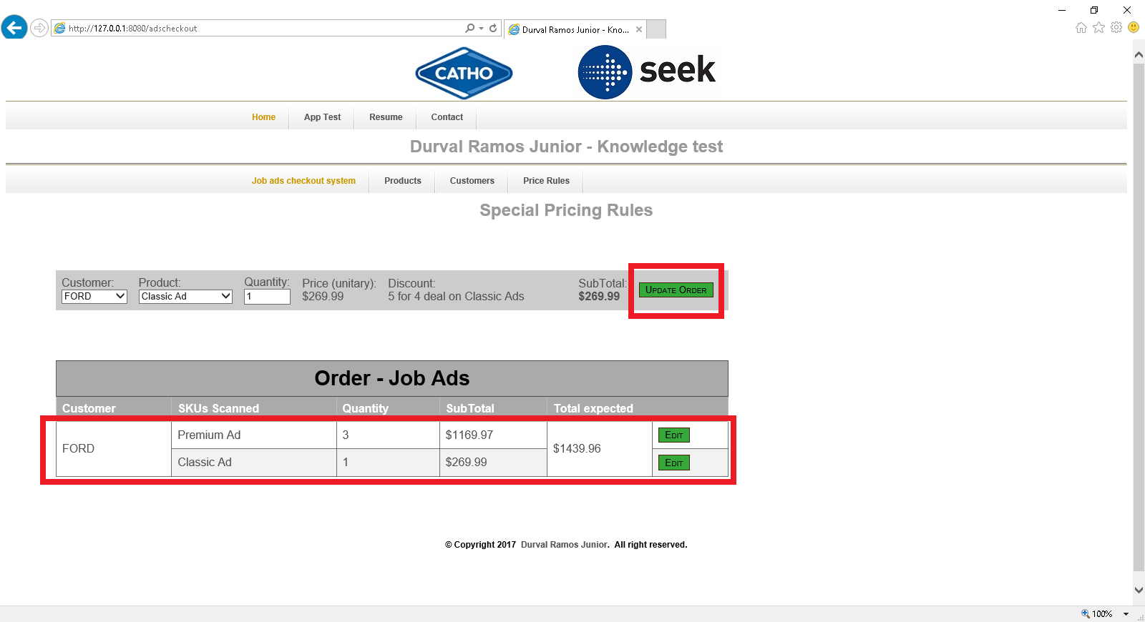

See below a sample the “Order” grid with several Customers/Products.

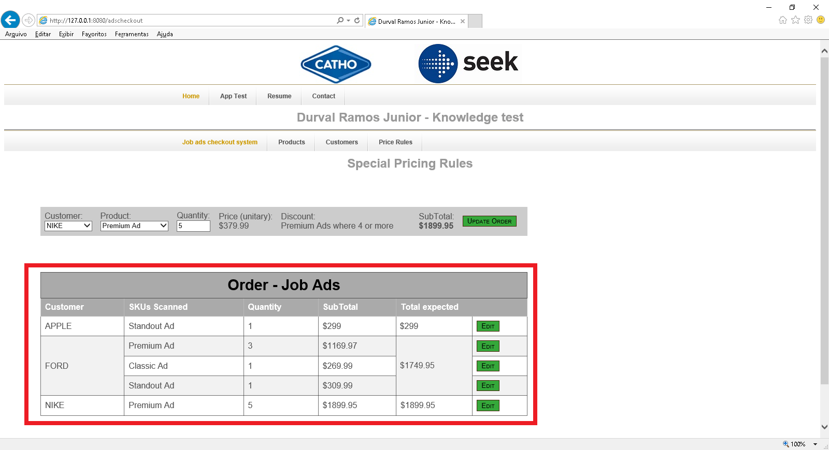

See below a Customer gets a discount on “Premium Ads where 3 or more” are purchased. The “Price (unitary)” and Subtotal fields are dynamic update process.

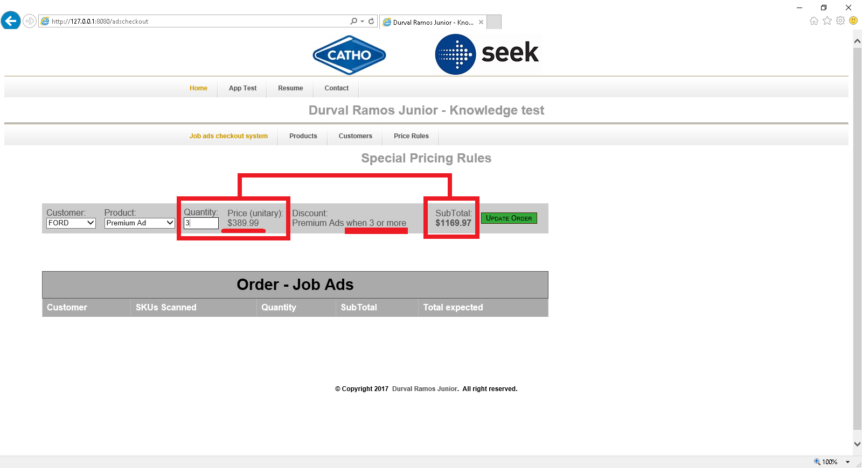

To edit quantity on Product adjustment in the Order list just click the “Edit” button.

